An Evaluation of UNCG’s University Libraries Website

Joseph LaSure

Dept. of Library and Information Science, UNC Greensboro

LIS 636: Website Production and Usability for Librarians

Dr. Zachary Frazier

August 31, 2022

In this essay, the author will briefly describe the website of UNCG’s University Libraries, in addition to suggesting user tasks for which the site may have been designed and evaluating how well the site facilitates these tasks.

The website showcases resources associated with both the library system—hereafter referred to simply as “the library”—itself and the university more broadly. For example, on the front page of the site, one finds a prominent search bar linked to the library’s online public access catalog (University of North Carolina at Greensboro [UNCG], n.d.d). The site also contains pages with information about the library as an institution, such as its organizational structure (UNCG, n.d.e) and contact information for its employees (UNCG, n.d.g). Additionally, there are resource guides (UNCG, n.d.c), an instant-messaging application (UNCG, n.d.a), and links to external sites, such as the university’s social media accounts and learning management system, i.e., Canvas (UNCG, n.d.d).

The elements are designed to meet various patron needs, the natures of which may be approximated from the tasks a site user might perform. For instance, in keeping with the library’s identity as an information organization, a patron may search for a specific publication or seek help from a staff member to find a resource suited to their needs. Finally, a user may seek to learn about the library, including where a student might study, to which staff member an inquiry might best be directed, and what technological resources are available.

In terms of the tasks listed above, it seems that the library website does a sufficient job empowering its users. Many of the site resources that are most likely to be needed, such as the simplified catalog search bar, are accessible from the front page. Moreover, these elements are in plain sight, which may also help minimize user frustration, as suggested by Krug (2014). That said, one thing that the site might do better is to increase readability on some currently text-heavy pages. For example, though the *Fast Facts* page uses bullet points, each point contains multiple lines of largely homogenous text, reducing the page’s readability, as seen below (UNCG, n.d.b).   
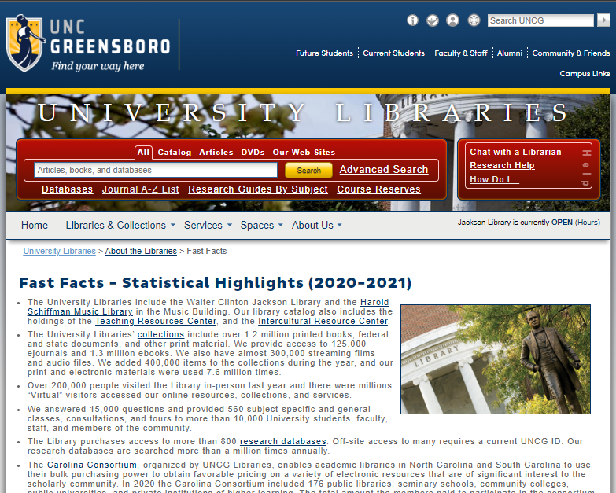

In summary, UNC Greensboro’s University Libraries website was likely designed with the typical clientele of academic libraries in mind, namely students, employees, and some non-affiliated patrons. This conclusion is supported by the site’s *University Library Services* page (UNCG, n.d.f), and is aligned with the widely accepted three-fold mission of higher education: teaching, research, and service (Evans & Greenwell, 2018). Thus, the site would likely fulfill most users’ needs; however, room for improvement remains.

**References**

Evans, G. E., & Greenwell, S. (2018). *Academic librarianship* (2nd ed.). ALA Neal-Schuman. <https://login.libproxy.uncg.edu/login?url=https://search.ebscohost.com/login.aspx?direct=true&db=nlebk&AN=1863458&site=ehost-live>.

Krug, S. (2014). *Don’t make me think, revisited: A common sense approach to web usability* (3rd ed.). New Riders.

University of North Carolina at Greensboro. (n.d.a). *Ask us!.* Retrieved August 31, 2022, from [https://library.uncg.edu/info/ask_us.aspx.](https://library.uncg.edu/info/ask_us.aspx. )

University of North Carolina at Greensboro. (n.d.b). *Fast facts - Statistical highlights (2020-2021).* Retrieved August 27, 2022, from <https://library.uncg.edu/info/fast_facts.aspx>.

University of North Carolina at Greensboro. (n.d.c). *Research guides by subject.* Retrieved August 27, 2022, from <https://library.uncg.edu/research/guides/>.

University of North Carolina at Greensboro. (n.d.d). *University libraries.* Retrieved August 27, 2022, from <https://library.uncg.edu/>.

University of North Carolina at Greensboro. (n.d.e). *University libraries departments.* Retrieved August 27, 2022, from <https://library.uncg.edu/info/depts/>.

University of North Carolina at Greensboro. (n.d.f). *University libraries services.* Retrieved August 31, 2022, from <https://library.uncg.edu/services/>.

University of North Carolina at Greensboro. (n.d.g). *University libraries staff.* Retrieved August 27, 2022, from <https://library.uncg.edu/info/staff.aspx>.